PROJECT REPORT

ON

“EXAM MANAGEMENT SYSTEM”

Submitted to
G H Raisoni Institute of Engineering & Technology, Nagpur

In partial fulfillment for the requirement of the degree of
Master in Computer Application
(MCA I Year, Semester II)

Submitted by

Mr. Satyam R Pandey

Guided by

Prof. Yogesh Sonvane
(Asst. Professor, Dept. of Computer Application, GHRIET, Nagpur)



G. H. Raisoni Institute of Engineering & Technology, Nagpur
Department of Computer Application

2023-24

G. H. Raisoni Institute of Engineering & Technology, Nagpur
Department of Computer Application
2023-24

CERTIFICATE

This is to certify that the project titled “Exam Management System” has been submitted by Mr. Satyam R Pandey in partial fulfillment for the requirement of the degree of Master in Computer Application (MCA) I Year, Semester II. This is an original work carried out by him/ under the guidance of Prof. Yogesh Sonvane and he have undergone the requisite hours of project work as specified by Rashtrasant Tukadoji Maharaj Nagpur University, Nagpur.

Prof. Yogesh Sonvane  Asst. Professor, MCA Dept.  GHRIET, Nagpur |  | Dr. Sandhya Dahake  HOD, MCA Dept.  GHRIET, Nagpur
Dr. Vivek Kapur
Director,
GHRIET, Nagpur

(Internal Examiner) (External Examiner)

Date –
Place – Nagpur

G. H. Raisoni Institute of Engineering & Technology, Nagpur
Department of Computer Application
2023-24

ACKNOWLEDGEMENT

I wish to thank my project guide Prof. Yogesh Sonvane for their supervision and guidance in the development of this project.

I also extend my gratitude to our Director, Dr. Vivek Kapur and Head of Department Dr. Sandhya Dahake for their support.

I also thanks to our teachers and friends for their support in developing this project.

Mr. Satyam R Pandey

MCA I Year, Semester II
GHRIET, Nagpur

INDEX

CHAPTER  NO. | TITLE | PAGE NO.
1. | INTRODUCTION  - Problem Definition  - Overview of the present working system  - Drawbacks of the present working system  - Overview of proposed system  - Advantages of the proposed system  - Scope of proposed system
2. | SYSTEM ANALYSIS  2.1 Identification of Need  2.2 Preliminary Investigation  2.3 Feasibility Study  - Economic Feasibility  - Operational Feasibility  - Technical Feasibility  2.4 Project Planning  2.5 Software requirement  2.6 Entity Relationship Diagram
3. | SYSTEM DESIGN (Whatever applicable)  3.1 Modularisation details  3.2 Database Design  3.3 Data Dictionary  3.4 Data Flow Diagram  3.5 System Flowchart  3.6 Program Flowcharts  3.7 Input Output Screens Designs (Dummy Layout)
4. | CODING: Source Code
5. | SYSTEM TESTING  5.1 Program Testing  5.2 Module Testing  5.3 Integration Testing  5.4 System Testing
6. | INPUT\OUTPUT SCREENS AND REPORTS  6.1 Sample Input\Output Screens  6.2 Reports
7. | LIMITATIONS AND FUTURE SCOPE  7.1 Limitations of the System  7.2 Future Scope of the System
8. | CONCLUSION
9. | REFERENCES

- INTRODUCTION

Exam Management System is a technology-driven way to simplify examination activities like defining exam patterns with question banks, defining exam timers, objective/ subjective question sections, and conducting exams using a computer in a paperless manner.
It can simplify overall examination management and result in generation activity.
Some basic features of an exam management system may include:
- Exam creation tools, such as the ability to create multiple choice.
- Exam administration tools, such as the ability to randomly generate exams and set time limits
- Results analysis tools, such as the ability to track student progress and generate reports
- Security features, such as the ability to prevent cheating by using remote proctoring and other anti-cheating measures

1.1 Problem Definition

An Exam Management System (EMS) is a digital platform used to create, conduct, and manage examinations within various contexts, including educational institutions, certification bodies, and corporate training programs in HR departments. It streamlines the process of exam administration, from setting up test papers to grading and reporting, leveraging technology to facilitate efficient and secure exams.

1.2 Overview of the Present Working System

Currently, in system we just conduct the MCQ type paper pattern and all necessary modules are added in the program. In this application student attend the exam and show the result after the paper submission and admin able to add, update, delete question according his requirement and paper pattern.

1.3 Drawbacks of the Present Working System

- In current working system, admin not able to conduct the programming paper.
- Exam only conduct in MCQ’s pattern.
- Admin does not able to conduct the paper Subject wise, exam que are mixed.

  - Overview of Proposed System

An exam management system is a software application that is designed to help educators create and administer exams, quizzes, and tests. Automating the process of creating and administering exams, which can save time and reduce the risk of errors. Allowing for the creation of exams that are tailored to the needs of specific students or groups of students. Providing tools for analyzing exam results and tracking student progress
  - Advantages of the Proposed System

Exam creation tools, such as the ability to create multiple choice, true/false, and short answer questions. Exam administration tools, such as the ability to randomly generate exams and set time limits. Results analysis tools, such as the ability to track student progress and generate reports. Security features, such as the ability to prevent cheating by using remote proctoring and other anti-cheating measures

1.6 Scope of Proposed System

The online examination management system wants to make evaluating exams easier for teachers. Instead of collecting stacks of paper answer sheets, students can submit their exams online through the system. This saves time and reduces the risk of losing important answers.
Additionally, the system has a special feature that automatically grades multiple-choice questions, making the evaluation process faster and more accurate. So, teachers can focus on giving feedback and guiding students towards improvement.

2 SYSTEM ANALYSIS

2.1 Identification of Need

An exam management system is a powerful tool that simplifies the entire exam process, from creating question papers to evaluating answers and generating reports. By automating these tasks, it allows educators to focus on teaching and providing personalized support to students.
In this era of technological and digital advancements, students are exposed to technology at an early age, and it’s crucial for educators to keep up with the trend. Exam management systems have revolutionized the way educational institutes manage student performance.

2.2 Preliminary Investigation

A preliminary investigation was conducted to assess the current landscape of Exam management systems. This investigation involved gathering information on existing platforms, analyzing user feedback, and identifying key pain points and areas for improvement.

2.3 Feasibility Study

A comprehensive feasibility study was conducted to evaluate the viability of implementing a new system for recurring Exam management system. This study encompassed economic, operational, and technical feasibility assessments.

- Economic Feasibility: The economic feasibility analysis involved estimating the costs associated with developing and implementing the proposed system, as well as projecting potential returns on investment. Factors such as development costs, maintenance expenses, and revenue generation potential were considered to determine the financial viability of the project.
- Operational Feasibility: Operational feasibility was assessed to determine whether the proposed system aligns with the operational processes and objectives of the organization. This involved evaluating factors such as user acceptance, resource availability, and organizational readiness to adopt the new system.
- Technical Feasibility: The technical feasibility analysis focused on assessing the technical capabilities and requirements necessary to develop and deploy the proposed system. Factors such as compatibility with existing systems, scalability, security, and regulatory compliance were evaluated to determine the technical feasibility of the project.

2.4 Project Planning

Based on the findings of the feasibility study, a comprehensive project plan was developed to guide the implementation of the proposed system. This plan outlined key milestones, timelines, resource allocations, and risk mitigation strategies to ensure the successful execution of the project.

2.5 Software Requirement

  - Software: - OS Windows 11.
  - Language: - JAVA.
  - Fronted: - JAVA , JFRAME.
  - Backend: - SQL.
  - Code Editor :- Net Beans

2.6 Entity Relationship Diagram

An Entity Relationship Diagram (ERD) was constructed to visually represent the relationships between various entities within the proposed system. This diagram helped to clarify the structure of the system and facilitate the design and development process. Key entities included Student, Admin, Login , Registration, Manipulate Question, Result.

In summary, the system analysis phase provided valuable insights into the need for a new system for recurring deposit online collection, as well as the feasibility of implementing such a system. By conducting thorough investigations and assessments, the groundwork was laid for the successful planning and execution of the project.

- SYSTEM DESIGN

3.1 Modularisation details:-

The modularization of the Exam Management System is essential for organizing its components into manageable and cohesive units. Each module encapsulates specific functionalities, facilitating ease of development, maintenance, and scalability. Below are the key modules identified for the system:

There are two Modules :-
- Student
- Registration :- In this section, Student enter his/her all details and register himself/herself for the exam .
- Start Exam :- After Registration student start the exam and he/she to give exam until the exam session on over after the exam session is over then
- Result :- After Student submit the exam student able to see the exam results. \

- Admin
- Login :- For conduct the Exam and manipulate the Question admin should login with correct login and password.
- Add Question :- After Admin logged In then he able to add the question and this question are Stored in the database.
- Update Question :- Suppose the Admin want to change some option in question or correct any spelling problem in question so admin will change the question any time.
- Delete Question ;- After the conducted exam is over then Admin delete the all question from database from this module.
- All Question :- Admin see how many question in the exam.
- All results :- Admin see result of all participants.

3.2 Database Design
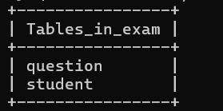

3.3 Data Dictionary
- Question Table :-
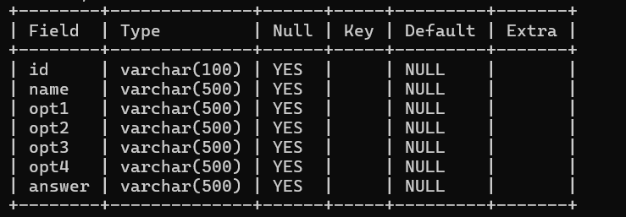

- Student Table

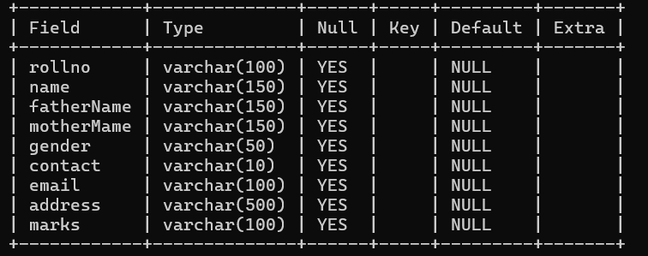

3.4 DATA FLOW DIAGRAM (DFD/ER Diagram): -
Exam Management System

Student
Admin
Register
Start Exam Session
Exam Submit
View Result
Login
Add Question
Update Question
Delete Question
Conduct Examination
Session Management
View Students
View Question
Manage Result

  - Input Output Screens Designs (Dummy Layout):

- Home Page


- CODING
First Page( Code):-
import javax.swing.JOptionPane;
public class index extends javax.swing.JFrame {
public index() {
initComponents();
}
private void jButton3ActionPerformed(java.awt.event.ActionEvent evt) {
int a = JOptionPane.showConfirmDialog(null,"Do you really want to Exit Application","select",JOptionPane.YES_NO_OPTION);
if(a==0){
System.exit(0);
}
}
private void jButton2ActionPerformed(java.awt.event.ActionEvent evt) {
setVisible(false);
new loginAdmin().setVisible(true);
}
private void jButton1ActionPerformed(java.awt.event.ActionEvent evt) {
// TODO add your handling code here:
setVisible(false);
new StudentRegistration().setVisible(true);
}
public static void main(String args[]) {

java.awt.EventQueue.invokeLater(new Runnable() {
public void run() {
new index().setVisible(true);}
});
}

// Variables declaration - do not modify
private javax.swing.JButton jButton1;
private javax.swing.JButton jButton2;
private javax.swing.JButton jButton3;
private javax.swing.JLabel jLabel1;
private javax.swing.JLabel jLabel2;
// End of variables declaration
}
- Student Registration (Code) :-
import java.sql.*;
import java.util.Date;
import java.text.SimpleDateFormat;
import java.awt.Color;
import javax.swing.JFrame;
import javax.swing.JOptionPane;
import project.ConnectionProvider;

public class StudentRegistration extends javax.swing.JFrame {
public StudentRegistration() {
initComponents();
jTextArea1.setEditable(false);
SimpleDateFormat dFormat =new SimpleDateFormat("dd-MM-yyyy");
Date date =new Date();
jLabel11.setText(dFormat.format(date)); }
private void jButton1ActionPerformed(java.awt.event.ActionEvent evt) {
// TODO add your handling code here:
setVisible(false);
new index().setVisible(true);
}

private void jButton2ActionPerformed(java.awt.event.ActionEvent evt) {
String rollno = jTextField1.getText();
String name =jTextField2.getText();
String fathername =jTextField3.getText();
String mothername =jTextField4.getText();
String gender=(String) jComboBox1.getSelectedItem();
String mobileno =jTextField6.getText();
String email =jTextField7.getText();
String address =jTextField8.getText();
String marks ="0";
try{
Connection con = ConnectionProvider.getCon();
PreparedStatement ps = con.prepareStatement("INSERT INTO student VALUES (?, ?, ?, ?, ?, ?, ?,?,?)");
ps.setString(1, rollno);
ps.setString(2, name);
ps.setString(3, fathername);
ps.setString(4, mothername);
ps.setString(5,gender );
ps.setString(6, mobileno);
ps.setString(7, email);
ps.setString(8, address);
ps.setString(9, marks);
ps.execute();
setVisible(false);
new InstructionStudent(rollno).setVisible(true);

}
catch(Exception e)
{
JFrame jf = new JFrame();
jf.setAlwaysOnTop(true);
JOptionPane.showMessageDialog(jf,e);
}
}

private void jButton3ActionPerformed(java.awt.event.ActionEvent evt) {
jTextField1.setText("");
jTextField2.setText("");
jTextField3.setText("");
jTextField4.setText("");
jComboBox1.getSelectedIndex();
jTextField6.setText("");
jTextField7.setText("");
jTextField8.setText("");
}
public static void main(String args[]) {
/* Create and display the form */
java.awt.EventQueue.invokeLater(new Runnable() {
public void run() {
new StudentRegistration().setVisible(true);
}
});
}

// Variables declaration - do not modify
private javax.swing.JButton jButton1;
private javax.swing.JButton jButton2;
private javax.swing.JButton jButton3;
private javax.swing.JCheckBox jCheckBox1;
private javax.swing.JComboBox<String> jComboBox1;
private javax.swing.JLabel jLabel1;
private javax.swing.JLabel jLabel10;
private javax.swing.JLabel jLabel11;
private javax.swing.JLabel jLabel12;
private javax.swing.JLabel jLabel2;
private javax.swing.JLabel jLabel3;
private javax.swing.JLabel jLabel4;
private javax.swing.JLabel jLabel5;
private javax.swing.JLabel jLabel6;
private javax.swing.JLabel jLabel7;
private javax.swing.JLabel jLabel8;
private javax.swing.JLabel jLabel9;
private javax.swing.JScrollPane jScrollPane1;
private javax.swing.JSeparator jSeparator1;
private javax.swing.JTextArea jTextArea1;
private javax.swing.JTextField jTextField1;
private javax.swing.JTextField jTextField2;
private javax.swing.JTextField jTextField3;
private javax.swing.JTextField jTextField4;
private javax.swing.JTextField jTextField6;
private javax.swing.JTextField jTextField7;
private javax.swing.JTextField jTextField8;
// End of variables declaration
}

Exam Section (Output Screenshot):-
import project.ConnectionProvider;
import java.sql.*;
import java.awt.event.ActionEvent;
import java.awt.event.ActionListener;
import java.text.SimpleDateFormat;
import java.util.Date;
import javax.swing.JOptionPane;
import javax.swing.Timer
public class QuizeExamStudent extends javax.swing.JFrame {
public String question ="1";
public String answer;
public int min=0;
public int sec=0;
public int marks =0;
public void answerCheck()
{
String studentAnswer ="";
if(jRadioButton1.isSelected())
{
studentAnswer=jRadioButton1.getText();
}
else if(jRadioButton2.isSelected())
{
studentAnswer=jRadioButton2.getText();
}
else if(jRadioButton3.isSelected())
{
studentAnswer=jRadioButton3.getText();
}
else
{
studentAnswer=jRadioButton4.getText();
}
if(studentAnswer.equals(answer))
{
marks =marks+1;
String marks1=String.valueOf(marks);
jLabel18.setText(marks1);
}
int questionId1 =Integer.parseInt(question);
questionId1 =questionId1+1;
question=String.valueOf(questionId1);
jRadioButton1.setSelected(false);
jRadioButton2.setSelected(false);
jRadioButton3.setSelected(false);
jRadioButton4.setSelected(false);
if(question.equals("10"))
{
jButton1.setVisible(false);
}
}
public void question() {
try{
Connection con = ConnectionProvider.getCon();
Statement st =con.createStatement();
ResultSet rs1=st.executeQuery("select*from question where id='"+question+"'");
while(rs1.next()){
jLabel16.setText(rs1.getString(1));
jLabel19.setText(rs1.getString(2));
jRadioButton1.setText(rs1.getString(3));
jRadioButton2.setText(rs1.getString(4));
jRadioButton3.setText(rs1.getString(5));
jRadioButton4.setText(rs1.getString(6));
answer =rs1.getString(7);
}
}
catch(Exception e){
JOptionPane.showMessageDialog(null, e);
}
}
public void submit()
{
String rollno= jLabel10.getText();
answerCheck();
try{
Connection con= ConnectionProvider.getCon();
Statement st = con.createStatement();
st.executeUpdate("update student set marks ='"+marks+"' where rollno ='"+rollno+"'");
String marks1 =String.valueOf(marks);
setVisible(false);
new SuccessfullySubmited(marks1).setVisible(true);
}
catch(Exception e)
{
JOptionPane.showMessageDialog(null, e);
}
}
public QuizeExamStudent() {
initComponents();
}
Timer time;
public QuizeExamStudent(String rollno) {
initComponents();
jLabel10.setText(rollno);
SimpleDateFormat dformat = new SimpleDateFormat("dd-MM-yyyy");
Date date= new Date();
jLabel2.setText(dformat.format(date));
try{
Connection con = ConnectionProvider.getCon();
Statement st =con.createStatement();
ResultSet rs=st.executeQuery("select*from student where rollno = '"+rollno+"'");
while(rs.next()){
jLabel12.setText(rs.getString(2));
}
ResultSet rs1=st.executeQuery("select*from question where id='"+question+"'");
while(rs1.next()){
jLabel16.setText(rs1.getString(1));
jLabel19.setText(rs1.getString(2));
jRadioButton1.setText(rs1.getString(3));
jRadioButton2.setText(rs1.getString(4));
jRadioButton3.setText(rs1.getString(5));
jRadioButton4.setText(rs1.getString(6));
answer =rs1.getString(7);
}
}
catch(Exception e){
JOptionPane.showMessageDialog(null, e);
}
setLocationRelativeTo(this);
time = new Timer(1000,new ActionListener(){
@Override
public void actionPerformed(ActionEvent e){
jLabel20.setText(String.valueOf(sec));
jLabel8.setText(String.valueOf(min));
if(sec ==60){
sec=0;
min++;
if(min==10)
{
time.stop();
answerCheck();
submit();
}
}
sec++;
}
});
time.start();
}
private void jButton1ActionPerformed(java.awt.event.ActionEvent evt) {
answerCheck();
question();
}

private void jButton2ActionPerformed(java.awt.event.ActionEvent evt) {
// TODO add your handling code here:
int a =JOptionPane.showConfirmDialog(null, "Do you really want to submit","Select",JOptionPane.YES_NO_OPTION);
if(a==0)
{
answerCheck();
submit();
}
}

private void jRadioButton1ActionPerformed(java.awt.event.ActionEvent evt) {
if(jRadioButton1.isSelected())
{
jRadioButton2.setSelected(false);
jRadioButton3.setSelected(false);
jRadioButton4.setSelected(false);
}
}

private void jRadioButton2ActionPerformed(java.awt.event.ActionEvent evt) {
if(jRadioButton2.isSelected())
{
jRadioButton1.setSelected(false);
jRadioButton3.setSelected(false);
jRadioButton4.setSelected(false);
}
}
private void jRadioButton3ActionPerformed(java.awt.event.ActionEvent evt) {
if(jRadioButton3.isSelected())
{
jRadioButton2.setSelected(false);
jRadioButton1.setSelected(false);
jRadioButton4.setSelected(false);
}
}
private void jRadioButton4ActionPerformed(java.awt.event.ActionEvent evt) {
if(jRadioButton4.isSelected())
{
jRadioButton2.setSelected(false);
jRadioButton3.setSelected(false);
jRadioButton1.setSelected(false);
}
}
public static void main(String args[]) {
java.awt.EventQueue.invokeLater(new Runnable() {
public void run() {
new QuizeExamStudent().setVisible(true);
}
});
}

private javax.swing.JButton jButton1;
private javax.swing.JButton jButton2;
private javax.swing.JLabel jLabel1;
private javax.swing.JLabel jLabel10;
private javax.swing.JLabel jLabel11;
private javax.swing.JLabel jLabel12;
private javax.swing.JLabel jLabel13;
private javax.swing.JLabel jLabel14;
private javax.swing.JLabel jLabel15;
private javax.swing.JLabel jLabel16;
private javax.swing.JLabel jLabel17;
private javax.swing.JLabel jLabel18;
private javax.swing.JLabel jLabel19;
private javax.swing.JLabel jLabel2;
private javax.swing.JLabel jLabel20;
private javax.swing.JLabel jLabel3;
private javax.swing.JLabel jLabel4;
private javax.swing.JLabel jLabel5;
private javax.swing.JLabel jLabel6;
private javax.swing.JLabel jLabel7;
private javax.swing.JLabel jLabel8;
private javax.swing.JLabel jLabel9;
private javax.swing.JPanel jPanel1;
private javax.swing.JPanel jPanel2;
private javax.swing.JPanel jPanel3;
private javax.swing.JPanel jPanel4;
private javax.swing.JPanel jPanel5;
private javax.swing.JRadioButton jRadioButton1;
private javax.swing.JRadioButton jRadioButton2;
private javax.swing.JRadioButton jRadioButton3;
private javax.swing.JRadioButton jRadioButton4;
// End of variables declaration
}

Admin Loggin (Code)
import javax.swing.ImageIcon;
import javax.swing.JOptionPane;
public class loginAdmin extends javax.swing.JFrame {
public loginAdmin() {
initComponents();
}
private void jCheckBox1ActionPerformed(java.awt.event.ActionEvent evt) {
if(jCheckBox1.isSelected()){
jPasswordField1.setEchoChar((char)0);}
else{
jPasswordField1.setEchoChar('*'); }
}
private void jButton2ActionPerformed(java.awt.event.ActionEvent evt) {
setVisible(false);
new index().setVisible(true);
}
private void jButton1ActionPerformed(java.awt.event.ActionEvent evt) {
if (jTextField1.getText().equals("qems") && jPasswordField1.getText().equals("admin")){
setVisible(false);
new adminHome().setVisible(true);}
else {
ImageIcon icon = new ImageIcon("Incorrect Password.png");
JOptionPane.showMessageDialog(null,"<html><b style=\"color:red; font-size:10px\">Incorrect<br>UserName Or Password</b></html>","Show",JOptionPane.INFORMATION_MESSAGE,icon );
}
}
public static void main(String args[]) {
java.awt.EventQueue.invokeLater(new Runnable() {
public void run() {
new loginAdmin().setVisible(true);
}});
}
private javax.swing.JButton jButton1;
private javax.swing.JButton jButton2;
private javax.swing.JCheckBox jCheckBox1;
private javax.swing.JLabel jLabel1;
private javax.swing.JLabel jLabel2;
private javax.swing.JLabel jLabel3;
private javax.swing.JLabel jLabel4;
private javax.swing.JLabel jLabel5;
private javax.swing.JPasswordField jPasswordField1;
private javax.swing.JTextField jTextField1;
}

ADD QUESTION (Code):-
import java.sql.*;
import javax.swing.JFrame;
import javax.swing.JOptionPane;
import project.ConnectionProvider;

public class addquestion extends javax.swing.JFrame {
public addquestion() {
initComponents();
try{
Connection con = ConnectionProvider.getCon();
Statement st =con.createStatement();
ResultSet rs =st.executeQuery("select count(id) from Question");
if(rs.next())
{
int id =rs.getInt(1);
id =id+1;
String str =String.valueOf(id);
jLabel4.setText(str);
}
else{
jLabel4.setText("1");
}
}
catch(Exception e){
JFrame jf= new JFrame();
jf.setAlwaysOnTop(true);
JOptionPane.showMessageDialog(jf, e);
}
}
private void jButton2ActionPerformed(java.awt.event.ActionEvent evt) {
String id = jLabel4.getText();
String name =jTextField1.getText();
String opt1 =jTextField2.getText();
String opt2 =jTextField3.getText();
String opt3 =jTextField4.getText();
String opt4 =jTextField5.getText();
String answer =jTextField6.getText();
try{
Connection con= ConnectionProvider.getCon();
PreparedStatement ps = con.prepareStatement("INSERT INTO question(id, name, opt1, opt2, opt3, opt4, answer) VALUES (?, ?, ?, ?, ?, ?, ?)");
ps.setString(1, id);
ps.setString(2, name);
ps.setString(3, opt1);
ps.setString(4, opt2);
ps.setString(5, opt3);
ps.setString(6, opt4);
ps.setString(7, answer);
ps.executeUpdate();
JFrame jf = new JFrame();
jf.setAlwaysOnTop(true);
JOptionPane.showMessageDialog(jf,"Successfilly Update");
setVisible(false);
new addquestion().setVisible(true);
}
catch(Exception e){
JFrame jf = new JFrame();
jf.setAlwaysOnTop(true);
JOptionPane.showMessageDialog(jf,e);
}
}
private void jButton3ActionPerformed(java.awt.event.ActionEvent evt) {
jTextField1.setText("");
jTextField2.setText("");
jTextField3.setText("");
jTextField4.setText("");
jTextField5.setText("");
jTextField6.setText("");
}

private void jButton1ActionPerformed(java.awt.event.ActionEvent evt) {
setVisible(false);
new adminHome().setVisible(true);
}
public static void main(String args[]) {
java.awt.EventQueue.invokeLater(new Runnable() {
public void run() {
new addquestion().setVisible(true);
}
});
}
}

DELETE QUESTION(Code) :-
import java.sql.*;
import javax.swing.JFrame;
import javax.swing.JOptionPane;
import project.ConnectionProvider;
public class Deletequetion extends javax.swing.JFrame {
public Deletequetion() {
initComponents();
try{
}
catch(Exception e){
}
}
private void jButton1ActionPerformed(java.awt.event.ActionEvent evt) {
setVisible(false);
new adminHome().setVisible(true);
}
private void jButton2ActionPerformed(java.awt.event.ActionEvent evt) {
String id =jTextField1.getText();
try{
Connection con = ConnectionProvider.getCon();
PreparedStatement ps= con.prepareStatement("delete from question where id=?" );
ps.setString(1, id);
ps.executeUpdate();
JFrame jf =new JFrame();
jf.setAlwaysOnTop(true);
JOptionPane.showMessageDialog(jf,"Successfully Delete");
setVisible(false);
new Deletequetion().setVisible(true);
}
catch(Exception e){
JFrame jf =new JFrame();
jf.setAlwaysOnTop(true);
JOptionPane.showMessageDialog(jf, e);
}
}
private void jButton3ActionPerformed(java.awt.event.ActionEvent evt) {
String id = jTextField1.getText();
try{
Connection con = ConnectionProvider.getCon();
Statement st= con.createStatement();
ResultSet rs = st.executeQuery("select *from question where id='"+id+"'");
if(rs.next())
{
jTextField2.setText(rs.getString(2));
jTextField3.setText(rs.getString(3));
jTextField4.setText(rs.getString(4));
jTextField5.setText(rs.getString(5));
jTextField6.setText(rs.getString(6));
jTextField7.setText(rs.getString(7));
jTextField1.setEditable(false);
}
else{
JFrame jf =new JFrame();
jf.setAlwaysOnTop(true);
JOptionPane.showMessageDialog(jf, "Question Id does not Exist");
}
}
catch(Exception e){
JFrame jf =new JFrame();
jf.setAlwaysOnTop(true);
JOptionPane.showMessageDialog(jf, e);
}
}
private void jButton4ActionPerformed(java.awt.event.ActionEvent evt) {
jTextField1.setText("");
jTextField2.setText("");
jTextField3.setText("");
jTextField4.setText("");
jTextField5.setText("");
jTextField6.setText("");
jTextField7.setText("");
jTextField1.setEditable(true);
}
public static void main(String args[]) {
ava.awt.EventQueue.invokeLater(new Runnable() {
public void run() {
new Deletequetion().setVisible(true);
}
});
}
}

ALL QUESTION ( CODE):-
import java.sql.*;
import javax.swing.JOptionPane;
import net.proteanit.sql.DbUtils;
import project.ConnectionProvider;
public class Allquestion extends javax.swing.JFrame {
public Allquestion() {
initComponents();
try{
Connection con= ConnectionProvider.getCon();
Statement st = con.createStatement();
ResultSet rs =st.executeQuery("select*from question");
jTable1.setModel(DbUtils.resultSetToTableModel(rs));

}
catch(Exception e){
JOptionPane.showMessageDialog(null, e);
}
}
private void jButton1ActionPerformed(java.awt.event.ActionEvent evt) {
// TODO add your handling code here:
setVisible(false);
new adminHome().setVisible(true);
}
public static void main(String args[]) {
java.awt.EventQueue.invokeLater(new Runnable() {
public void run() {
new Allquestion().setVisible(true);
}
});
}
}

ALL RESULT (CODE) :-
import java.sql.*;
import javax.swing.JOptionPane;
import net.proteanit.sql.DbUtils;
import project.ConnectionProvider;
public class AllResult extends javax.swing.JFrame {
public AllResult() {
initComponents();
try{
Connection con = ConnectionProvider.getCon();
Statement st= con.createStatement();
ResultSet rs= st.executeQuery("select*from student");
jTable1.setModel(DbUtils.resultSetToTableModel(rs));
}
catch(Exception e)
{
JOptionPane.showMessageDialog(null, e);
}
}
private void jButton1ActionPerformed(java.awt.event.ActionEvent evt) {
setVisible(false);
new index().setVisible(true);
}
public static void main(String args[]) {
java.awt.EventQueue.invokeLater(new Runnable() {
public void run() {
new AllResult().setVisible(true);
}
});
}
private javax.swing.JButton jButton1;
private javax.swing.JLabel jLabel1;
private javax.swing.JLabel jLabel2;
private javax.swing.JScrollPane jScrollPane1;
private javax.swing.JSeparator jSeparator1;
private javax.swing.JTable jTable1;
}
- SYSTEM TESTING

5.1 Program Testing

Program testing in the context of EXAM MANAGEMENT SYSTEM involves the examination of individual software components that constitute the system. Developers conduct program testing to ensure that each program unit, such as user authentication modules, exam conduct properly, time session, Answer checking, operates correctly according to its specifications. Program testing helps identify and rectify any errors or bugs in the codebase, ensuring the reliability and integrity of the software.

5.2 Module Testing
Module testing focuses on evaluating the functionality and performance of discrete modules within the exam management system. Each module, representing a specific set of related functionalities, undergoes rigorous testing to verify its behavior and interactions with other modules. For instance, module testing may involve testing the user registration module, exam page module, question manipulation module, and all result module independently to ensure they function as intended and produce expected outputs.

5.3 Integration Testing

Integration testing assesses the integration and interaction between different modules or subsystems of the Exam management system. This testing phase verifies that the integrated components communicate effectively, Add question, and All results are showing. Integration testing scenarios may include testing the integration between the user interface and backend systems, integration between transaction processing modules, and integration with external banking systems to validate end-to-end functionality and interoperability.

5.4 System Testing

System testing evaluates the entire exam management system as a unified entity to confirm that it meets specified requirements and performs reliably in a production environment. This comprehensive testing phase examines the system's functionality, usability, performance, security, and compliance w
6 INPUT\OUTPUT SCREENS AND REPORTS

  - Sample Input\Output Screens

- Home Page

- Student ragistration page
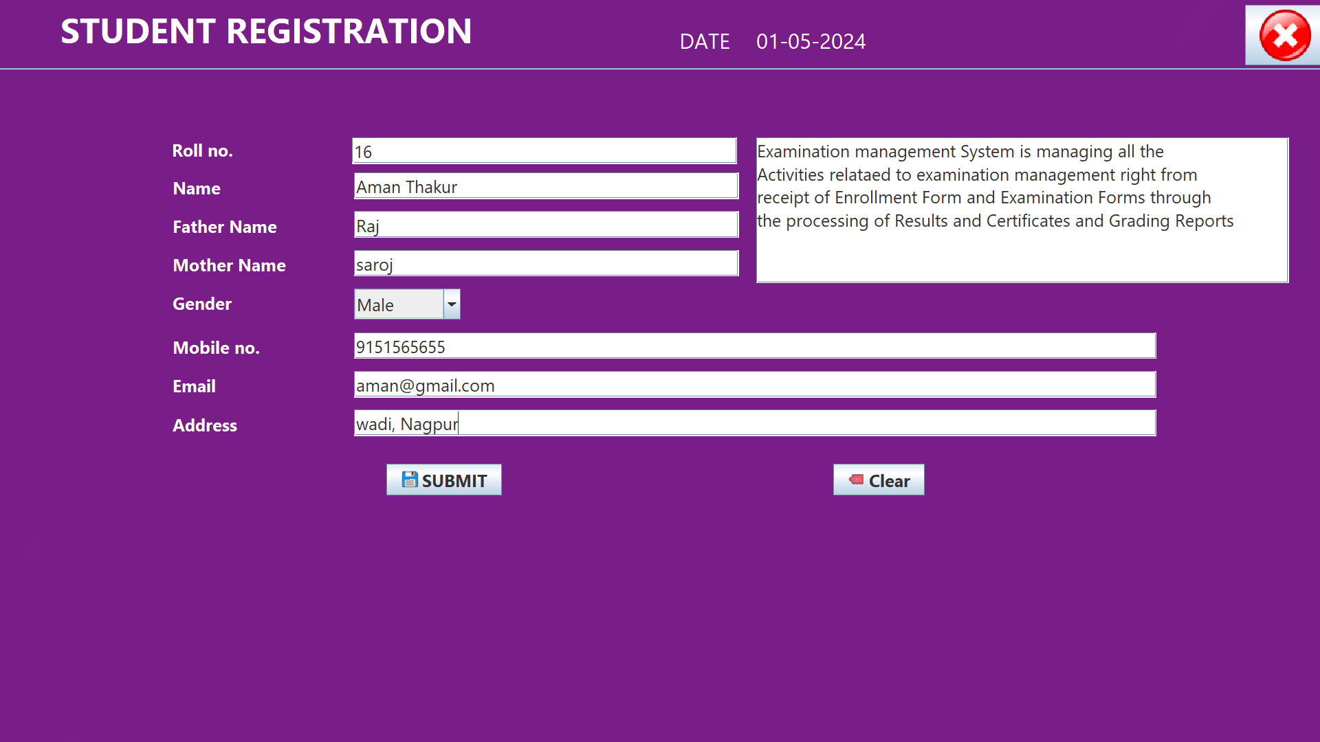

- Exam page
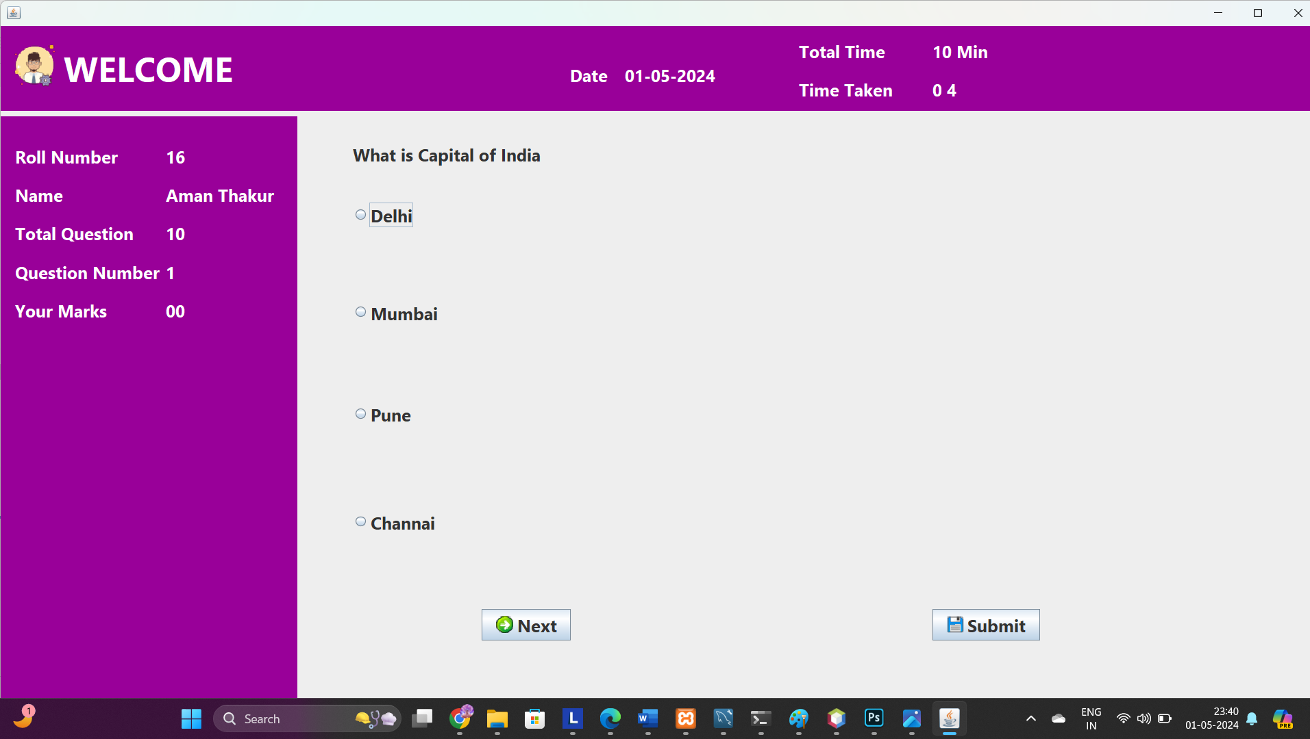

- Admin login
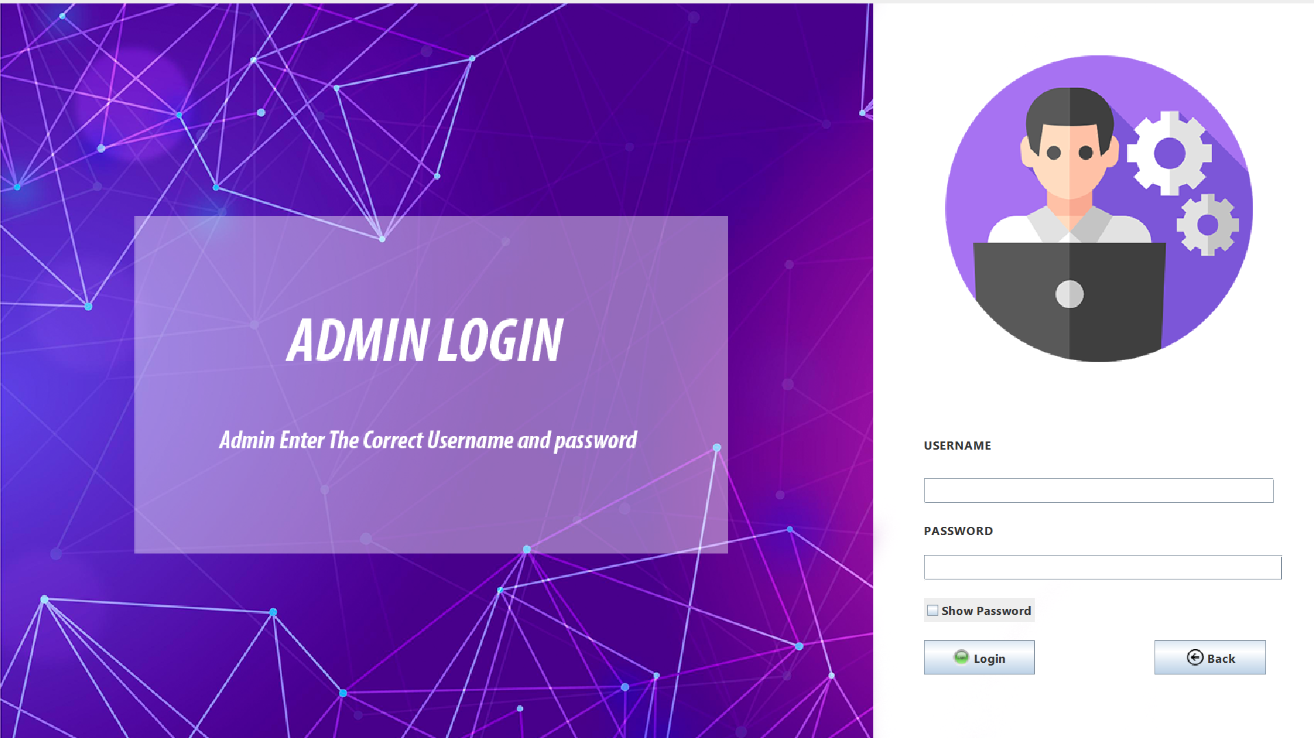

- Add question
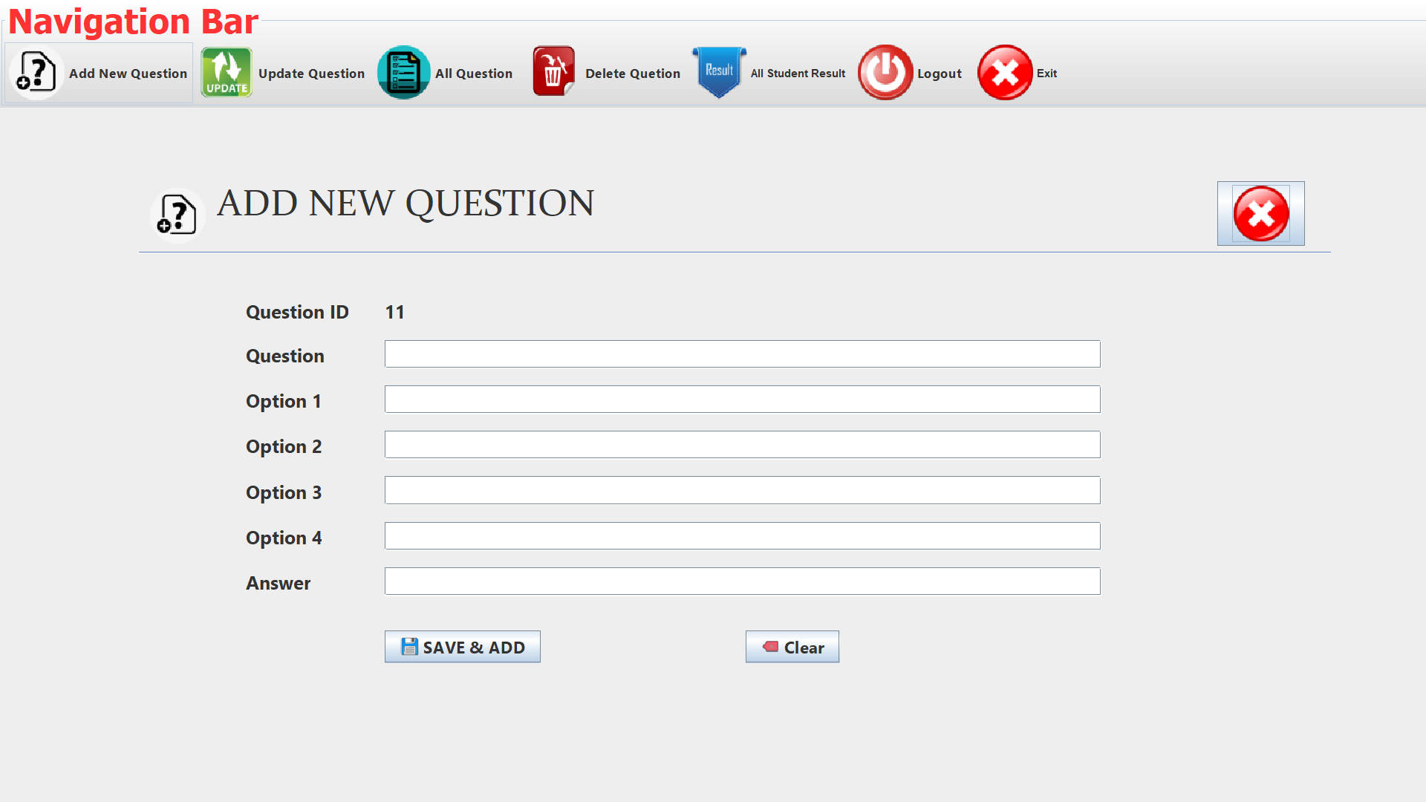

- Update Question
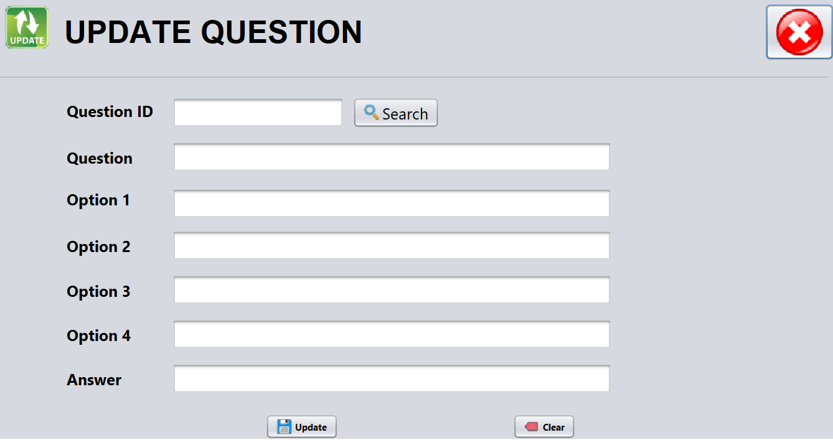

- Delete Question
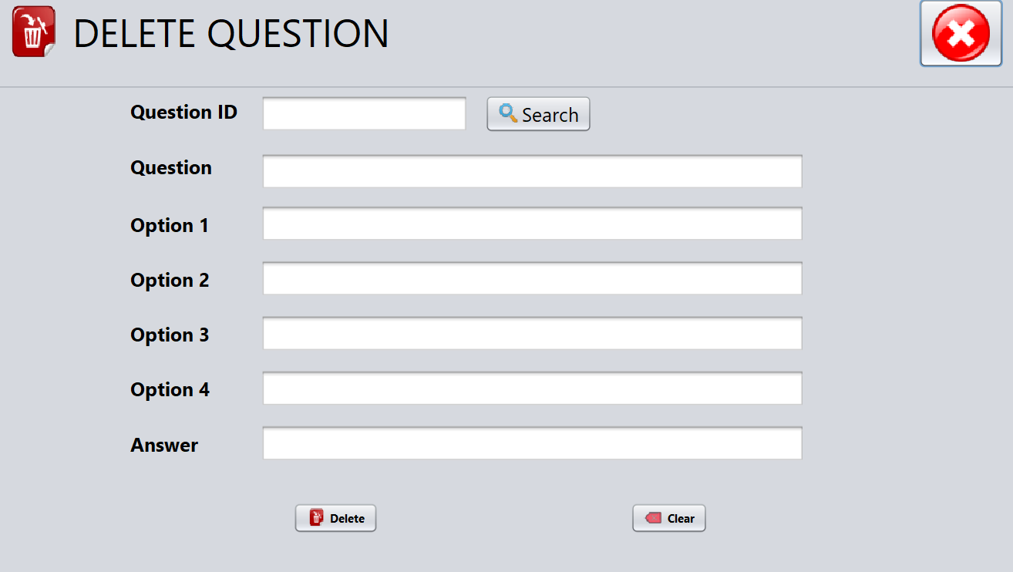

- All Question
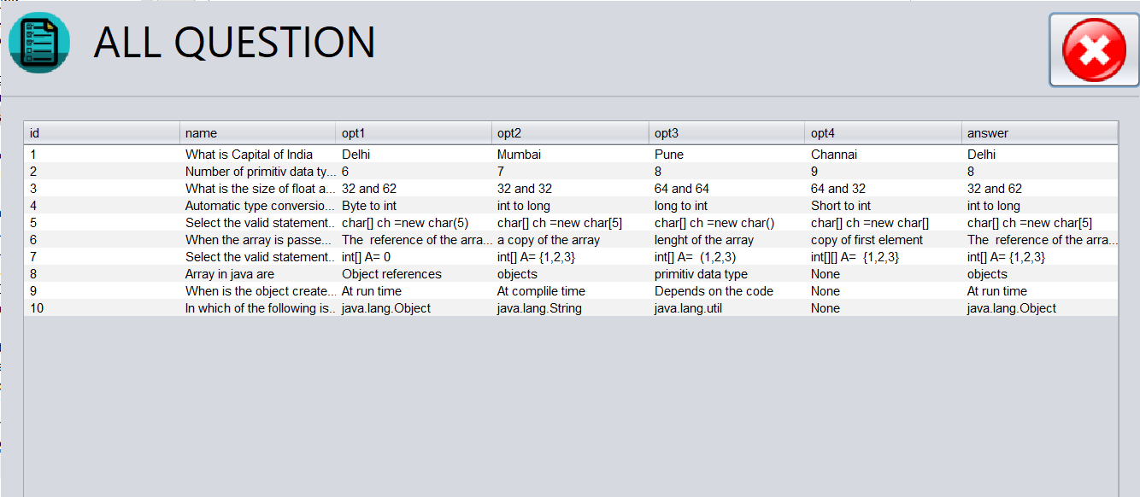

- All Result
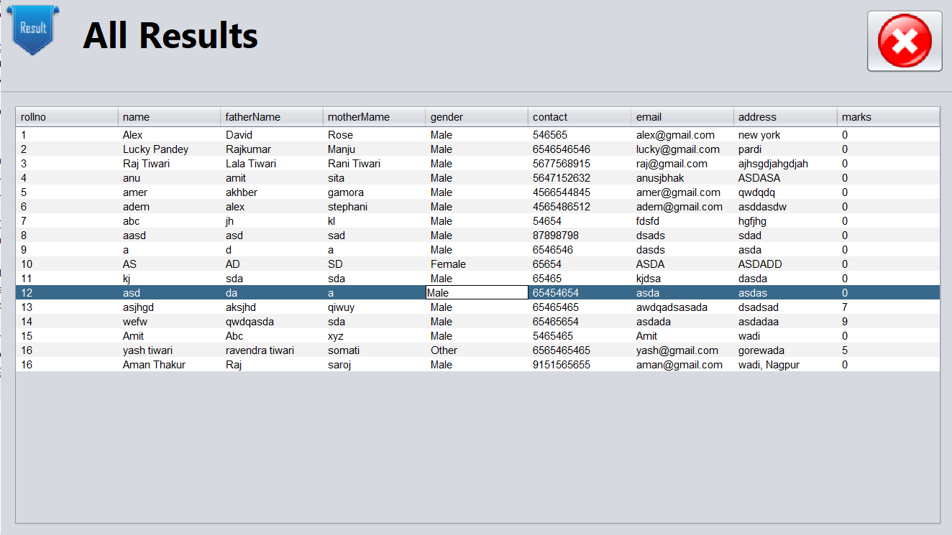

6.2 Reports

This section outlines the reports generated by the exam management system to provide users and administrators with insights into examination process:

1. Conduct Exam:
- If Admin want to conduct the exam then will enter the question and set the time session the system.

2. Student Registration:
- In this section student entre all of his/her information and register for exam.

3. Student Overview :
- After the exam over then admin will see all the student and all report how many student appear for exam.
4. Resul overview:-
7 LIMITATIONS AND FUTURE SCOPE

7.1 Limitations of the System

While the recurring deposit online collection system offers numerous advantages, it is important to acknowledge its limitations:

- Technical Constraints: The system's performance may be affected by technical constraints such as network latency, system downtime, and hardware limitations. These factors can impact the user experience and overall efficiency of the system.

- User Adoption: The success of the system relies on user adoption and acceptance. Resistance to change, lack of awareness, and usability issues may hinder the widespread adoption of the system among target users.

7.2 Future Scope of the System

Despite its limitations, the exam management system holds significant potential for enhancement and expansion. Future scope areas include:

01. Conduct exams effortless: Computer-based tests as a method of conducting an assessment enable users to manage an exam easily. The functionalities of an exam software such as user-friendly dashboard, multiple languages, support for multiple question types and formats, detailed reporting, automatic instant results help in smooth conduction.
02. Reduce exam anxiety Amongst test takers: The flexibility associated with computer-based tests reduces exam anxiety among test takers as they can take the exam at any time of the day that coincides with their preferred sleep/ wake cycle.
03. Promote social interaction between the test taker and experts: An online environment promotes exam preparation with experts or peers as they can review the course content together.

8. CONCLUSION

In conclusion, the development and implementation of the recurring deposit online collection system represent a significant advancement in modern financial management. Through systematic analysis, design, and testing, we have identified the need for a streamlined and secure platform to facilitate recurring deposit transactions in the digital age.

The system offers numerous advantages, including convenience, accessibility, and efficiency, enabling users to save and grow their funds with ease. However, it is essential to acknowledge the system's limitations, such as security concerns, technical constraints, and regulatory compliance issues. By addressing these challenges and embracing future scope areas, the system can evolve into a more robust and versatile platform that meets the diverse needs of users and stakeholders.

9. REFERENCES

1. https://www.geeksforgeeks.org
2. https://www.w3schools.com/
3. https://www.tutorialspoint.com/index.htm
4. https://www.javatpoint.com/
5. https://www.sourcecodester.com/

